9.49: a) 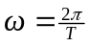, so Eq. (9.17) becomes 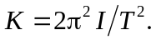
b) Differentiating the expression found in part (a) with respect to T,
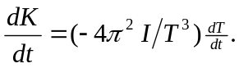
c)
d)

